PORT OF ILWACO
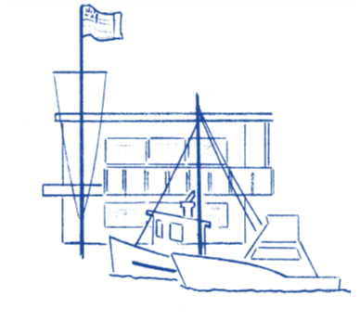

Notice of Special Meeting

NOTICE is hereby given that the Board of Commissioners of the Port of Ilwaco will be holding a “Special Meeting” on Thursday December 11, 2025, meeting which will begin at 3:00 pm. The purpose of this meeting is for Review of the Port Tariff. This meeting will take place at the Port of Ilwaco meeting room, located at 165 Howerton Way, Ilwaco WA 98624.

The Port of Ilwaco has provided an alternative option to attend our public meeting via conference call until further notice.
This hybrid meeting will be held using Zoom. Please copy and paste the link below to join:
https://us06web.zoom.us/j/83779087802?pwd=bzcyZXRLb2xCVnBWWEZGRVJRRHRFZz09
Join by calling: +1(253)215-8782
Meeting ID: 837 7908 7802
Passcode: 2022
Agenda

- Call to Order of Special Meeting
- Review Port Tariff
- Adjourn Special Meeting

