PORT OF ILWACO
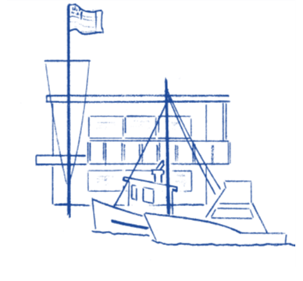

Notice of Special Meeting

NOTICE is hereby given that the Board of Commissioners of the Port of Ilwaco will be holding a Special Meeting at 3:00pm April 29,2025. This meeting will take place at the Port of Ilwaco meeting room, located at 165 Howerton Way, Ilwaco WA 98624.

The Port of Ilwaco has provided an alternative option to attend our public meeting via conference call until further notice.
This hybrid meeting will be held using Zoom. Please copy and paste the link below to join:
https://us06web.zoom.us/j/83779087802?pwd=bzcyZXRLb2xCVnBWWEZGRVJRRHRFZz09
Join by calling: +1(253)215-8782
Meeting ID: 837 7908 7802
Passcode: 2022
Agenda

- Approval of business plan for Lady Lou Pacific
- Public comment
- Executive Session ;To confer with legal counsel. R.C. W.42.30.110 (i)

